**HOME AUTOMATION**

**USING ARDUINO**

**Team members**

Arshiya Tabassum

Apoorva P

Siri B Y

Mohammed Salman

**Project Guide**

Mr Chethan L S

**Table of Contents**

1. **Introduction** 
   1. Purpose 3
   2. Scope 3
   3. Abbreviations 3
   4. References 4
   5. Technologies 4

**2) Overall Description**

2.1) Product Perspective 4

2.2) Software Interface 6

2.3) Hardware Interface 6

2.4) Hardware Description. 6

2.5) Communication Interface. 7

2.6) User Characteristics 7

2.7) Use-Case Model Survey 8

2.8) Architecture diagram. 9

2.9) Assumptions and Dependencies. 9

**3) Specific Requirements**

3.1) Use-Case Reports. 10

3.2) Supplementary Requirements**. 15**

**INTRODUCTION**

**Purpose**

The latest trend in the technologies related to wireless communication has led to the emergence of several engineering designs for human requirements. The creeping interests in the wireless and GSM based projects, we came up with this idea of developing a simpler, cost-effective design to control the on-off home lights via short message service (SMS). Commands are sent to home light for night lighting Applications system through user’s mobile as data through SMS (Short Service Messages) providing a cost effective, reliable far reaching access to the user. The coded SMS is sent to the light relay system to base station controller that receives the messages, decodes the messages, initiates required automation operations and responds to the successful initiations by a reply to the user.

**Scope**

Home automation is automation of the home or household activity. Home activity may include centralized control of lighting, appliances and security locks of the gates to provide improved convenience, comfort, energy efficiency and security. Home automation system integrates electrical devices in a house with each other. This technique includes control of domestic activities such as home entertainment systems, lighting control system and use of domestic robots. This also helps in saving of power.

**Abbreviations**

* **SRS**: Software Requirement Specification.
* **SMS:**Short Message Service**.**
* **GSM:**Global System for Mobile**.**
* **USB:**Universal Serial Bus**.**
* **RX:**Receiver.
* **TX:**Transmitter.
* **RFID:**Radio Frequency Identification**.**

**References**

* IEEE SRS Format
* TGMC sample SRS

**Technologies**

* Arduino IDE.

**1.6) Overview**

SRS will include two sections:

**Overall description** will brief about the components, interconnection and external interfaces of thesystem.

**Specific requirements** will include functions of actors, their role in the system and constraints.

**2.) Overall Description**

**2.1) Product Perspective**

Home automation is automation of the home or household activity. Home activity may include centralized control of lighting, appliances and security locks of the gates to provide improved convenience, comfort, energy efficiency and security. We are using GSM module (global system for mobile) as mobile device, which receives the message from the user and controls the all home appliances using relays by accepting input from the user.

RELAYS are the switches that open and close circuits electromechanically or electronically. In our project we are using relays to control the lighting system and all home appliances, because it can control the large voltage.

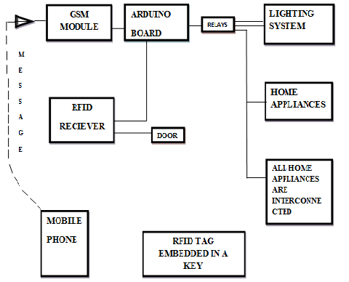

**Fig 2.1 Home Automation Simulation devices.**

**2.2) Software Interface**

* Arduino IDE.

**2.3) Hardware Interface**

1. Arduino UNO Board.
2. GSM Module.
3. RFID Device.
4. Relays.

**2.4) Hardware Description**

**2.4.1) Arduino UNO Board.**

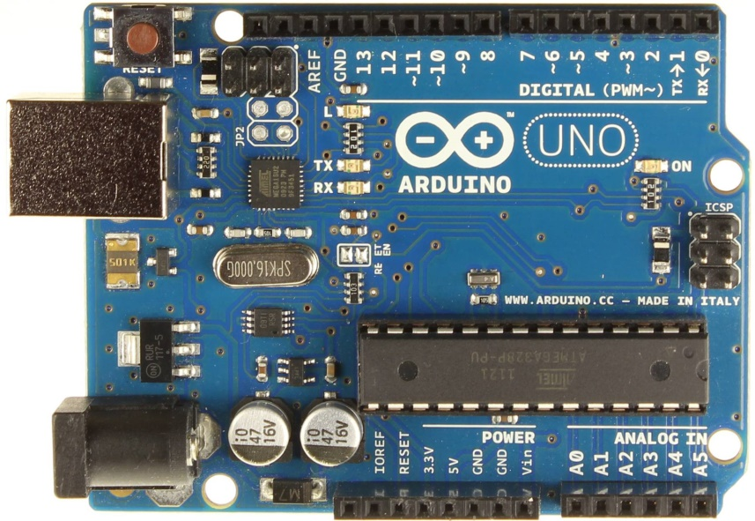

Fig 2.2 Arduino UNO board**.**

* The Uno is a microcontroller board based on the ATmega328P.
* It has 14 digital input/output pins (of which 6 can be used as PWM outputs), 6 analog inputs, a 16 MHz quartz crystal, a USB connection, a power jack, an ICSP header and a reset button.
* It contains everything needed to support the microcontroller; simply connect it to a computer with a USB cable or power it with a AC-to-DC adapter or battery to get started.
* Technical Specifications:

Table 2.1 technical specification of arduino.

|  |  |  |  |  |  |  |  |  |  |  |  |  |  |  |  |  |  |  |  |  |  |  |  |  |  |  |  |  |  |  |  |  |
| --- | --- | --- | --- | --- | --- | --- | --- | --- | --- | --- | --- | --- | --- | --- | --- | --- | --- | --- | --- | --- | --- | --- | --- | --- | --- | --- | --- | --- | --- | --- | --- | --- |
| |  |  | | --- | --- | | Microcontroller | ATmega328P | | Operating Voltage | 5V | | Input Voltage (recommended) | 7-12V | | Input Voltage (limit) | 6-20V | | Digital I/O Pins | 14 (of which 6 provide PWM output) | | PWM Digital I/O Pins | 6 | | Analog Input Pins | 6 | | DC Current per I/O Pin | 20 mA | | DC Current for 3.3V Pin | 50 mA | | Flash Memory | 32 KB (ATmega328P) of which 0.5 KB used by bootloader | | SRAM | 2 KB (ATmega328P) | | EEPROM | 1 KB (ATmega328P) | | Clock Speed | 16 MHz | | Length | 68.6 mm | | Width | 53.4 mm | | Weight | 25 g | |

**2.4.2) GSM Module**

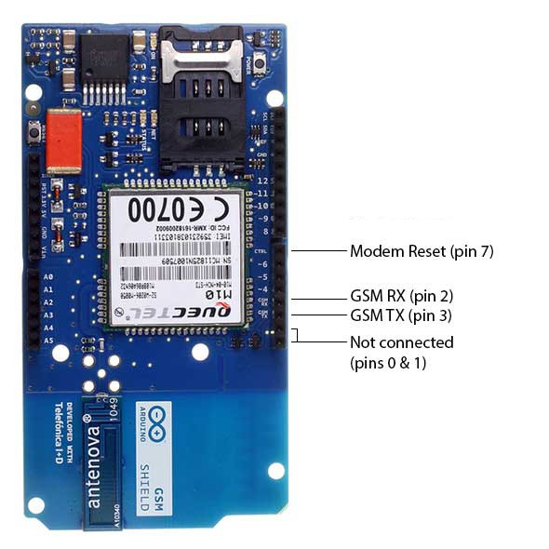

* Operating voltage 5V (supplied from the Arduino Board).
* Connection with Arduino Uno on pins 2, 3 (Software Serial) and 7 (reset)**.**
* The Arduino GSM Shield allows an Arduino board to connect to the internet, make/receive voice calls and send/receive SMS messages.

**2.5) Communication Interface**

* The Arduino GSM Shield allows an Arduino board to connect to the internet, make/receive voice calls and send/receive SMS messages.
* Simply Arduino to a computer with a USB cable.

**2.6) User Characteristics**

* Every user should be comfortable of working with mobile and net browsing. He must have basic knowledge of English too.

**2.7) Use-Case Model Survey**

<<extend>>

RFID receiver at Door

Arduino machine

Home owner

GSM module

<<extend>>

<<include>>

<<include>>

<<include>>

<<include>>

Fig 2.3 Use-case diagram of home automation.

1. **Home owner:**
2. **GSM module:**
3. **RFID receiver at door:**

**4) Arduino machine:**

**2.8) Architecture Diagram**

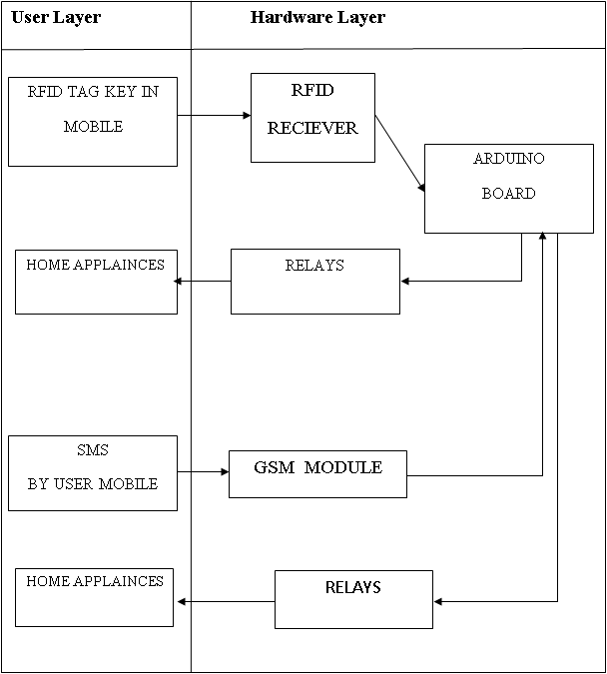

**Fig 2.4 Architectural diagram.**

**2.9) Assumptions and Dependencies**

* User should place and receive SMS with other SIMs on the Movilforum network.

**3) Specific Requirements**

**3.1) Use Case Report Use Case Reports**

1. **User:**

________________________________________________________________________

**Name of use case:** Send SMS

**Use case ID:** 1

**Actors:** User

**Description:** To send sms.

**Preconditions:**

* User should be knowing number of sim Card inserted inside GSM shield.

**Normal flow of events:**

**Alternate flow of events:**

**Post condition:** A user should have number of sim card inside GSM shield.

**_____________________________________________________________**

**Name of use case:** Validate user Number.

**Use case ID:** 2

**Actors:** User

**Description:** Verify user mobile number.

**Preconditions:**

**Normal flow of events:**

**Alternate flow of events:**

**Post condition:**

**3.1.1) Sequence diagram of ineraction of user,GSM and Arduino.**

**:User**

**:GSM**

**:Arduino**

**:Lights**

**:Relays**

sms

Switch(on/off)

connect()

connect()

connected

connected

action

response

responsese

responsese

**Fig 3.1 Sequence diagram of GSM and Arduino interaction.**

1. **USER:** When ever user wants to switch of the all home appliances using mobile phone he sends a message to GSM module.
2. **GSM:** GSM module act asmobile device which receives input from the user as a massage using relays it controls the all home appliances.
3. **Arduino:** To interact with different device we are using arduino board as a base board to establish the connection.
4. **Relays:** RELAYS are the switches that open and close circuits electromechanically or electronically. In our project we are using relays to control the lighting system and all home appliances, because it can control the large voltage.
5. **Lights:** RELAYS that are connected to lights acts as switch. When binary ‘0’ is sent as signal will turn off lights and when binary ‘1’ as signal will turn on lights.

**3.1.2) Sequence diagram of RFID working.**

**:Arduino**

**:RFIDreceiver At Door**

**:Relays**

**:RFID Tag key**

Switch(off)

connect ()

RFID status

connected

action

Key outside

responsese

responsese

response

RFID status

Switch(on)

connect()

connected

action

Key inside

response

response

response

**Fig 3.2 Sequence diagram of RFID working.**

The above shows how the interaction between different devices on the arduino board that may control the lightning system, Home appliances by performing specific function.

1. **RFID tag key:** Radio-Frequency identification (RFID) is the wireless use of electromagnetic fields to transfer data, for the purpose of automatically identifying and tracking tags attached to objects tags contain electronically stored information. Here we are using RFID as key.
2. **RFID Receiver at doors:** RFID receiver receives the tags attached to objects and transfer the control to the Arduino which perform functions to switch on and off of the home lighting system using the relays. Its function is to interrogate RFID tags. It contains RF module, which act as both transmitter and receiver of radio frequency signals.
3. **Relays:** whenever RFID receiver track the object it transfer the control to Arduino, which act as interface between hardware and the all home appliances using relays it perform two actions on and off of the all home appliances. After performing this action it will sends a message in response.

**3.3.3) Sequence diagram of interaction among hardware.**

**:GSM**

**:Arduino**

**:Relays**

**:Lights**

**:Fan**



smss

1

connect()

Switch on

response

connected

1

connect()

Switch on

connectededd

responsesese

0

smss

0

smss

**Fig 3.3 sequence diagram of Arduino interaction with Relays of home appliances.**

The above shows how the interaction between different devices on the arduino board that may control the lightning system, Home appliances by performing specific function.

1. **GSM:** GSM module act asmobile device which receives input from the user as a massage using relays it controls the all home appliances. Whenever we lock the door and key is removed automatically it sends a message to GSM module (global system for mobile) which acts as mobile device, which receives the message from the from RFID and controls the all home appliances using relays by accepting input from the user.
2. **Arduino:** To interact with different device we are using arduino board as a base board to establish the connection.
3. **Relays:** RELAYS are the switches that open and close circuits electromechanically or electronically. In our project we are using relays to control the lighting system and all home appliances, because it can control the large voltage. Using the remote devices such as mobile we can also control the lightning system and all home appliances by sending input message to the GSM module which receives the input from the user from mobile device and there by performing some specific functions it controls the lightning system using relay

**3.2) Supplementary Requirements**

* Provides 24x7 operation facility and security.
* Compatibility of using system from anywhere and anytime.
* Flexibility: Flexible service based architecture is designed for future extension.